Software Proposal for Imports Tracker

Submitted to: Rajchem Polymers Ltd

Date: 01-04-2025

# 1. Introduction

Rajchem Polymers Ltd engages in importing various raw materials essential for its manufacturing and distribution processes. Tracking the status of incoming goods from the point of order to final warehouse delivery is crucial for effective planning, minimizing delays, and optimizing inventory management.  
  
This proposal outlines the development of a custom Imports Tracker software to streamline and centralize the tracking of purchase orders and incoming shipments.

# 2. Objectives

The proposed Imports Tracker system aims to:  
- Provide a centralized platform for tracking imported goods.  
- Ensure visibility from the time a Purchase Order (PO) is placed to the time goods are received in the warehouse.  
- Improve communication between procurement, logistics, and warehouse teams.  
- Minimize manual tracking errors and inefficiencies.

# 3. Key Features

## 3.1 Purchase Order Capture

Input and store PO details such as:  
- PO Number  
- Supplier  
- Date of Order  
- Expected Arrival Date  
- Transit Required (Yes/No)  
- Origin Country / Port of Loading

## 3.2 Shipment Status Tracking

Update status of each PO through multiple milestones:  
- Goods Dispatched  
- Goods in Transit  
- Arrived at Port  
- Cleared from Port  
- Received at Warehouse  
- Track actual landing date and compare with expected date.

## 3.3 Status Flags & Notifications

Automatic reminders or alerts for:  
- Overdue shipments  
- Goods at port for more than [X] days  
- POs without warehouse confirmation after landing

## 3.4 Reporting Dashboard

Real time Visual summary of:  
- POs in various stages (ordered, in transit, landed, received)  
- Delays and pending actions  
- Monthly import summary reports

## 3.5 User Roles & Access

Define access levels for:  
- Procurement Officers  
- Logistics Team  
- Warehouse Staff  
- Admin/Supervisors

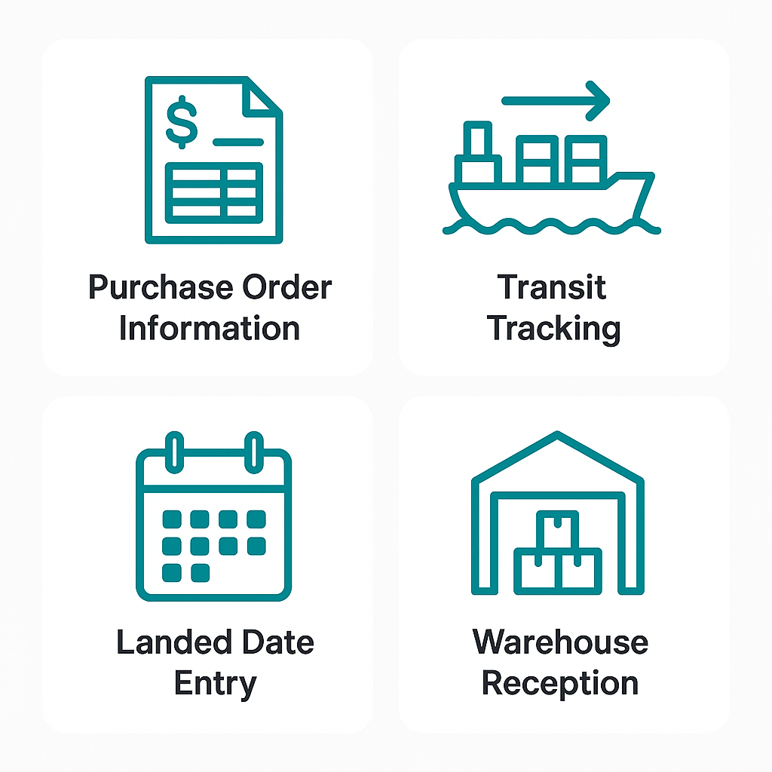

# 4. Benefits

- Improved visibility into shipment timelines  
- Real-time updates reduce manual follow-ups  
- Better planning of warehouse space and production  
- Minimized delays and demurrage risks  
- Data-driven decisions through reports and analytics

# Appendix: Process Flowchart

# 

Proposal: Sales Order Management System

Date: April 3, 2025

# 1. Objective

To develop a standalone Sales Order Management System that streamlines the sales process from order creation to approval, delivery, invoicing, and dispatch, with built-in user roles, workflows, and optional email notifications. The system will ensure accuracy, accountability, and real-time tracking without requiring integration with third-party platforms or ERP systems.

# 2. Key Modules

## 2.1 Sales Order Creation

* User: Uganda Manager
* Features:
* - Create a new Sales Order (Customer, Items, Delivery Date, Remarks)
* - Store orders in database with status "Pending Approval"
* - View own order history

## 2.2 Price & Credit Check

* User: KE Accountant
* Features:
* - Review Sales Orders
* - Add credit check and pricing remarks
* - Approve for next stage

## 2.3 Sales Order Approval

* User: KE Director
* Features:
* - View pending orders
* - Final approve or reject
* - Remarks saved in system

## 2.4 Loading Order Generation

* User: Uganda Manager
* Feature:
* - Auto-generate Loading Order upon SO approval
* - Notifies warehouse for fulfillment

## 2.5 Delivery Note (DN)

* User: Warehouse In-Charge
* Features:
* - Input quantity dispatched
* - Create a Delivery Note
* - Update inventory values (optional)

## 2.6 Invoice Management

* Users: KE Accountant, Uganda Manager
* Features:
* - Create invoice based on delivery
* - View historical invoices
* - Download/print invoice PDFs

## 2.7 Gate Pass Management

* User: Gate In-Charge
* Features:
* - View gate pass for confirmed deliveries
* - Mark as released

## 2.8 Reporting & Dashboards

* User: Admin / All Users
* Features:
* - Filterable sales dashboard
* - Export data to Excel/CSV
* - Track pending/approved/rejected orders

## 2.9 Notifications (Optional)

* Send email alerts on:
* - Order approvals
* - Dispatch readiness
* - Rejections

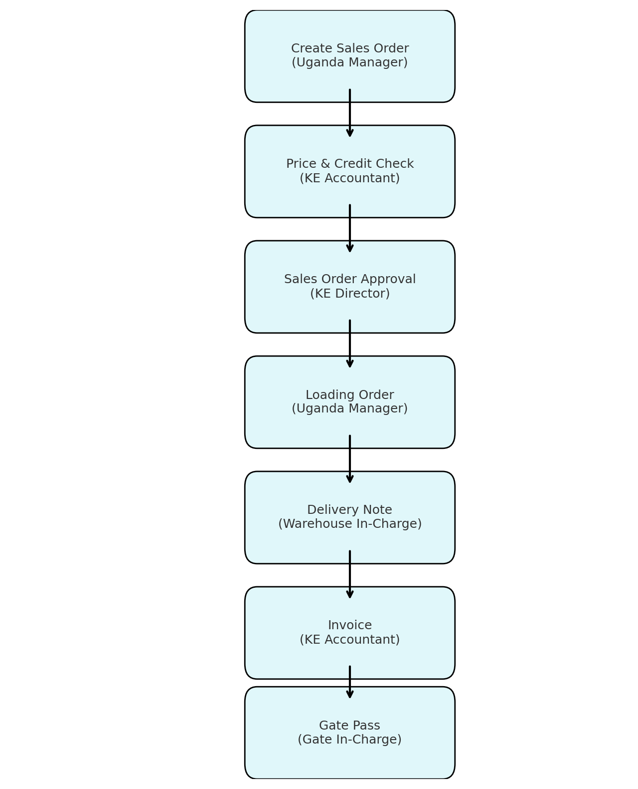

# 3. User Roles & Permissions

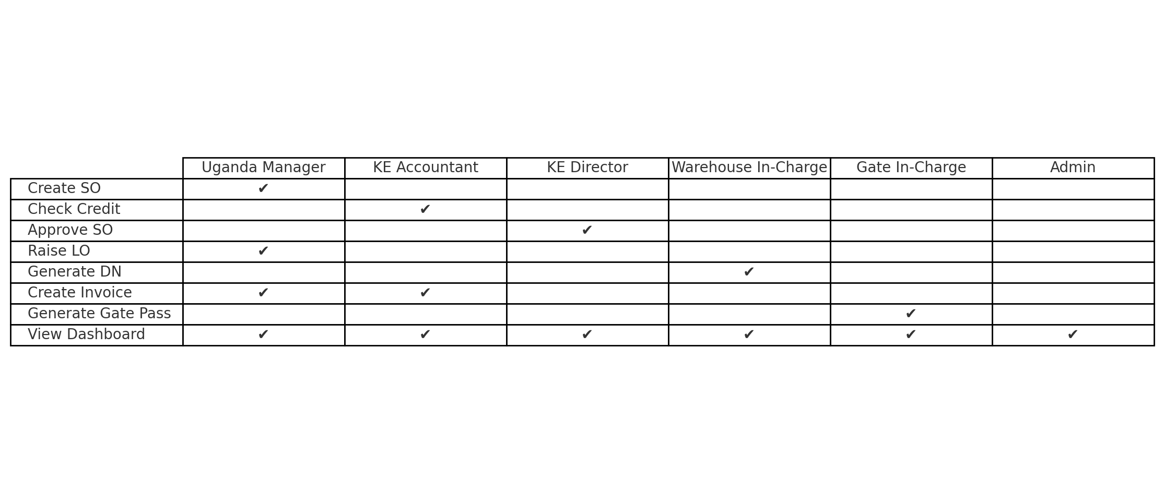

# 4. Benefits

* Streamlined internal approval process
* Centralized sales tracking
* Transparency across departments
* Audit logs for accountability
* Easy to deploy, extend, and maintain
* Real time notifications and Updates!

Costing Proposal: Software Packages

# Included Modules

1. **Sales Order Management System**
2. **Imports Tracker**
3. **Stock Counter**

# 2. Payment Options: Software Package

Below are two proposed payment models for the above mentioned Included Modules. SaaS-based monthly subscription or a one-time billing model.

# 1. SaaS Subscription Model

This option provides access to the software on a subscription basis, hosted and maintained by us.

|  |  |  |  |
| --- | --- | --- | --- |
| Description | Qty (Branches) | Unit Price (Ksh/month) | Total (Ksh/month) |
| Monthly Subscription Fee | 3 | 20,000 | 60,000 |
| Hosting & Maintenance | Included | - | Included |
| Support | Included | - | Included |

*Note: This is a recurring monthly fee. Discounts available for annual subscriptions. All prices are subject to VAT*

# 2. One-Time Billing Model

This option includes full system ownership, with deployment at three branches.

|  |  |  |
| --- | --- | --- |
| Item | Qty | Total (Ksh) |
| **Sales Order Management System** | 3 | 100,000 |
| **Imports Tracker** | 3 | 100,000 |
| **Stock Counter** | 3 | 100,000 |
| **Deployment, Setup & Training** | 1 | 100,000 |
| **Total Package Cost** | **400,000** | |

*Note: Ongoing support and upgrades can be purchased separately if needed. All prices are subject to VAT *

Custom features, future integrations can be quoted separately upon request.